Name: Muskan Chandiramani

Div: D10C

Roll No:5

# Practical No 2 : Elastic Beanstalk

1. 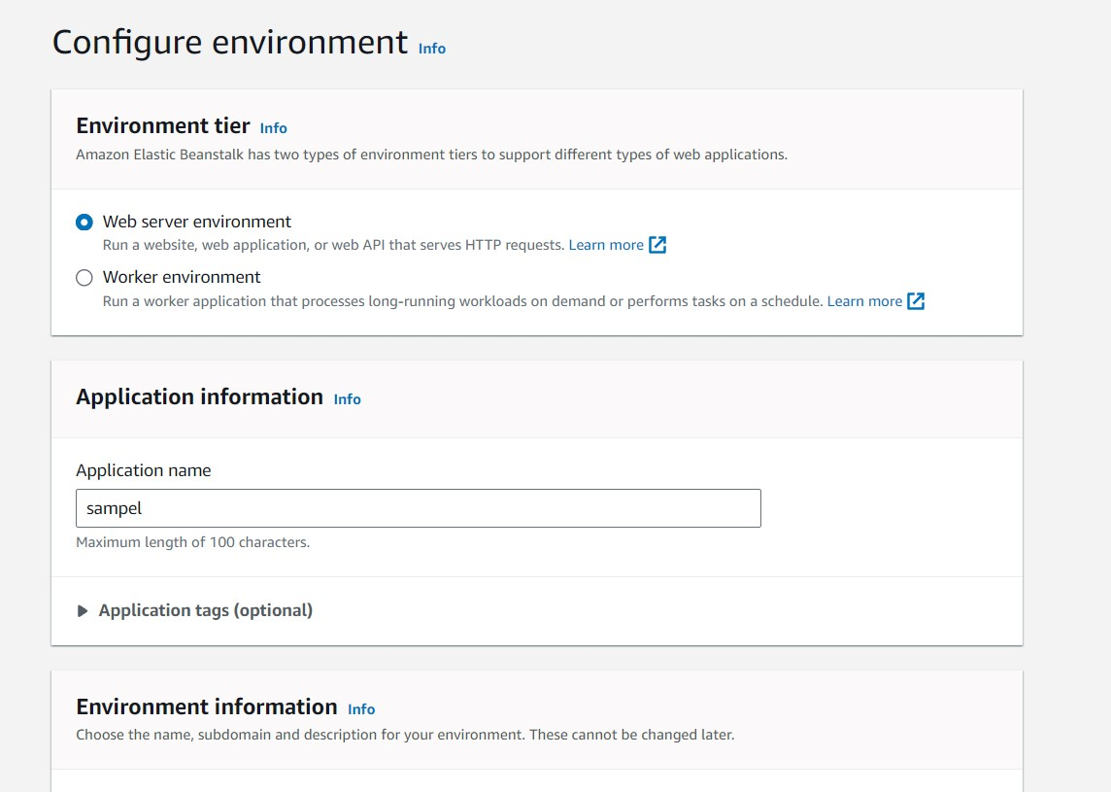Go to services and choose elastic Beanstalk.following page will appear.

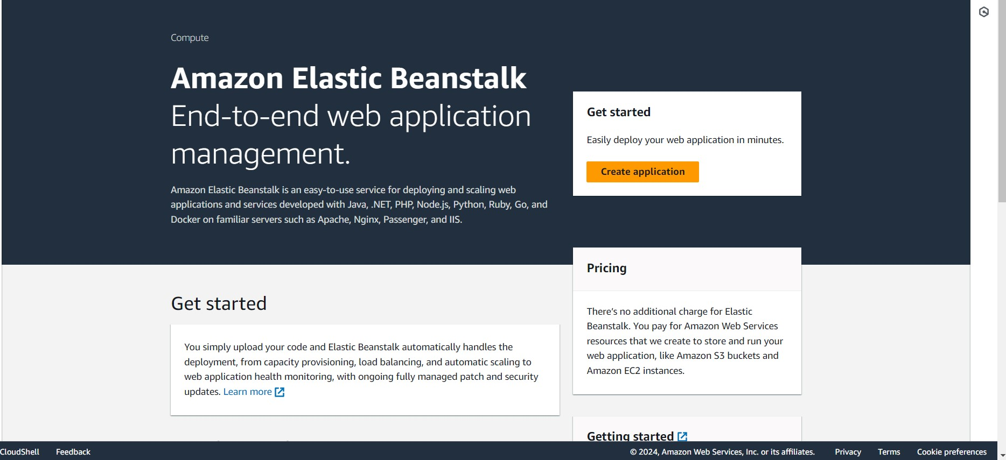

1. Configure the environment. Give the application name, check domain availability and choose PHP as platform.Then click next.
2. 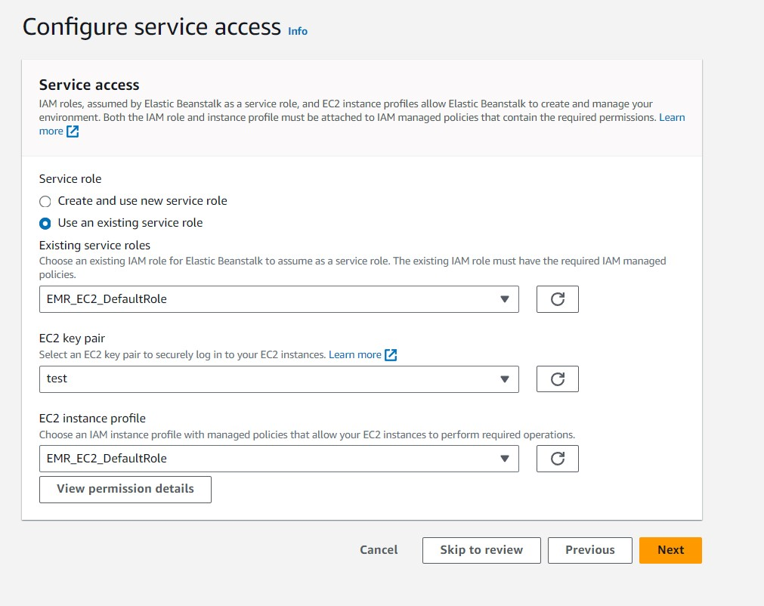Configure the service access. 4) Choose one of the available VPC and instance subnet.Click next.

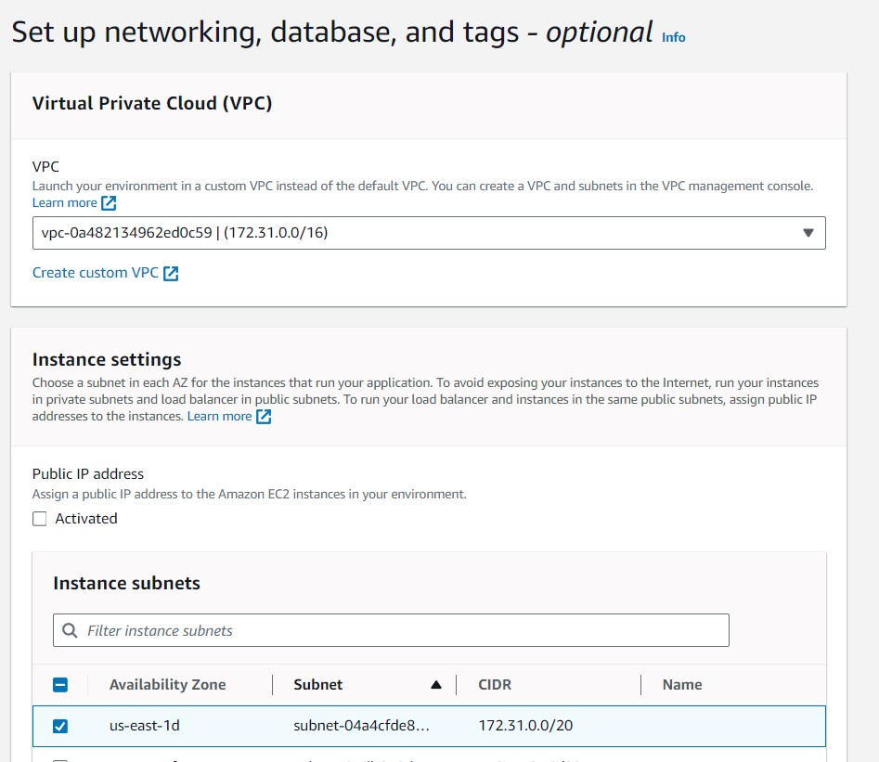

1. Configure instance traffic and scaling. Keep all the options as default.

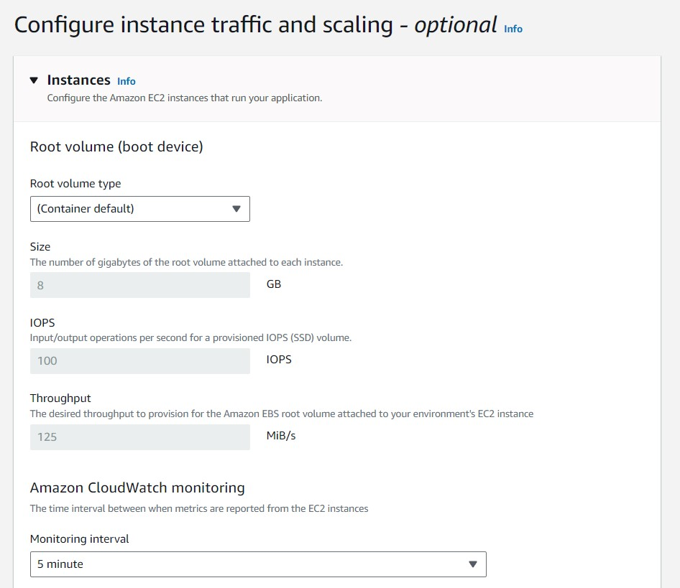

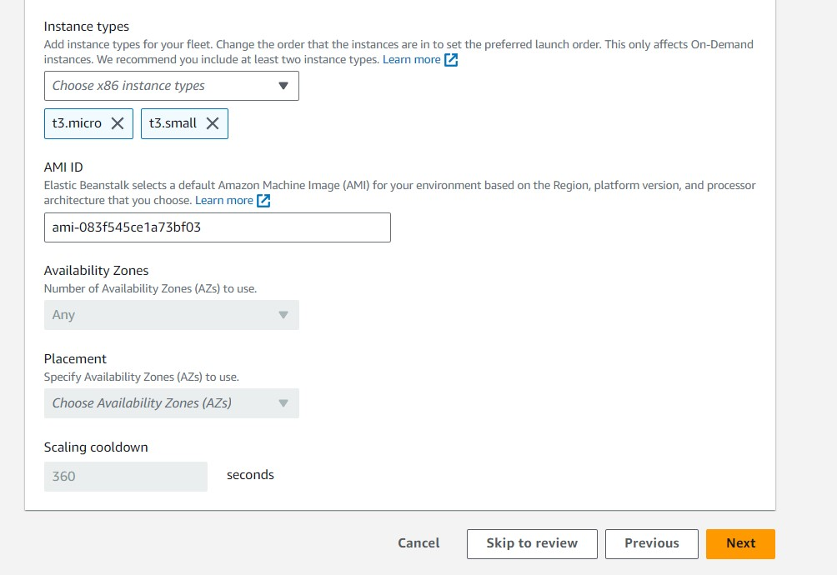

1. Configure updates, monitoring, and logging.Keep everything as default and click next.

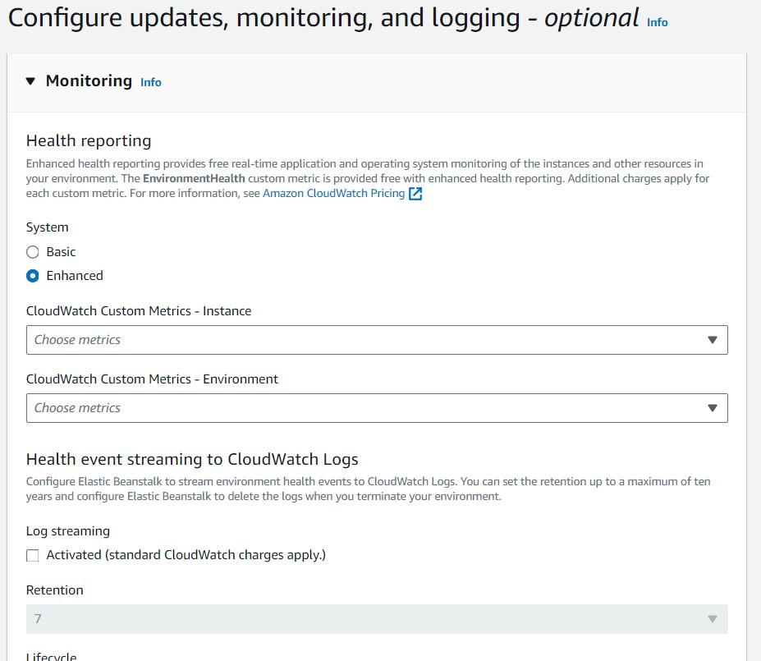

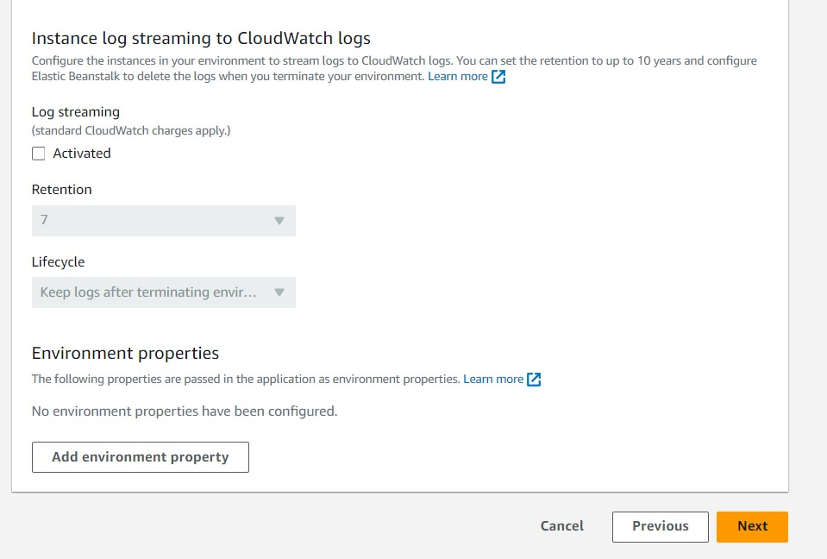

1. In the review section,click submit.

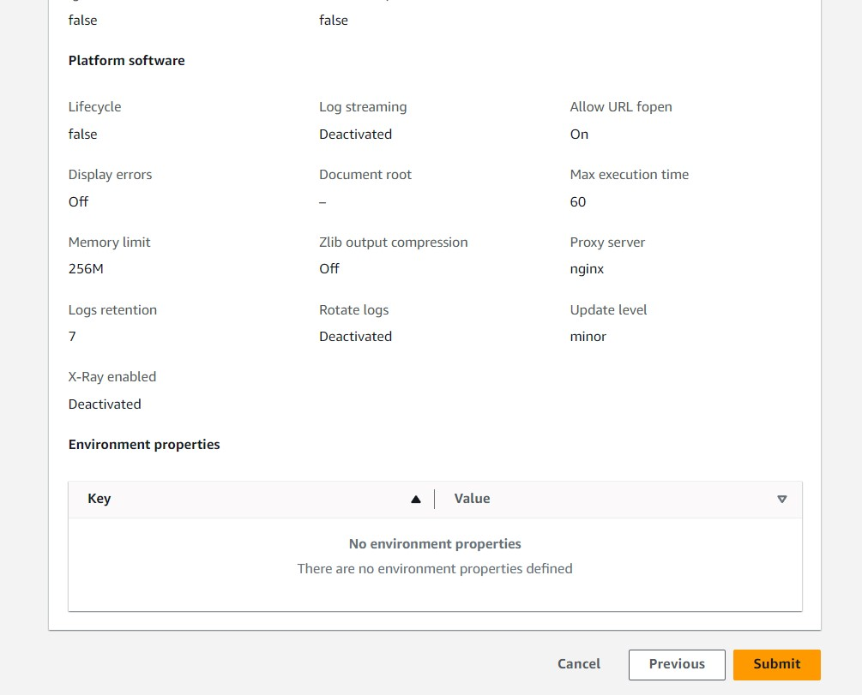

1. Environment has been created successfully.

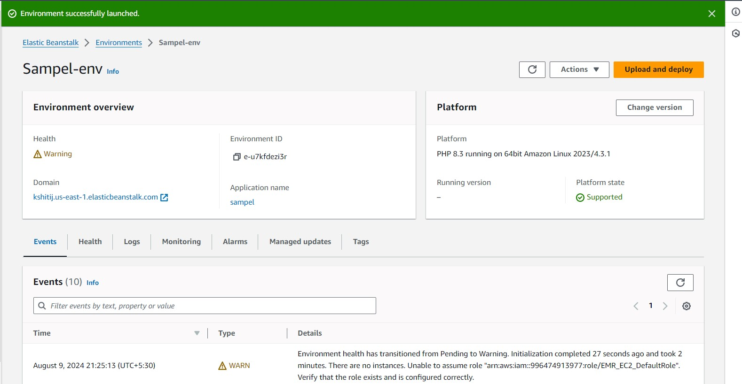

1. Deploy something on the recently created environment.

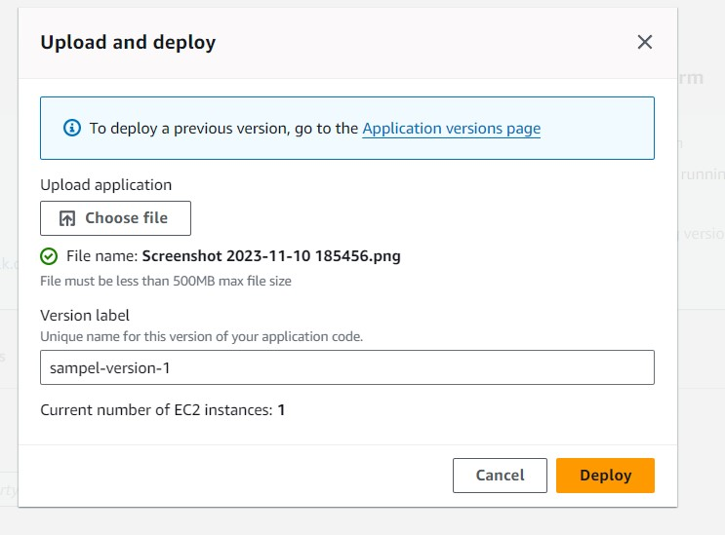

**Pipeline Creation:**

* 1. Fork a github repository. This forked repository will act as source for your code pipeline.



* 1. Go to developer tools and select CodePipeline and create a new pipeline

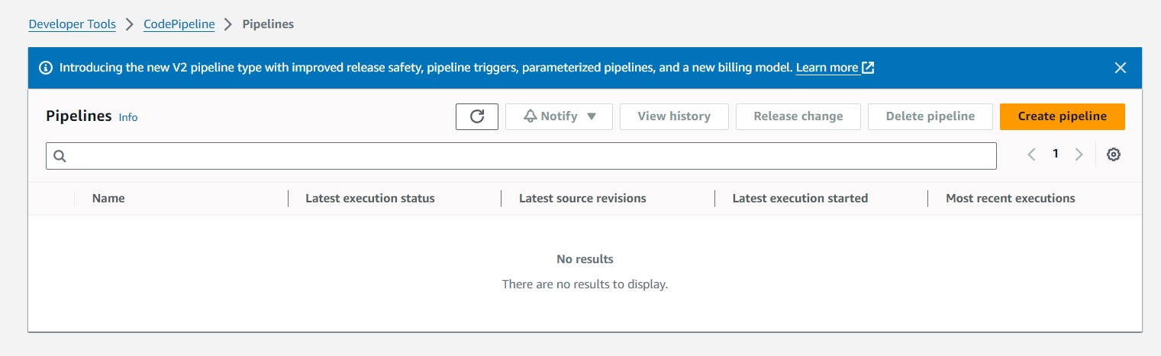

* 1. Create a pipeline:

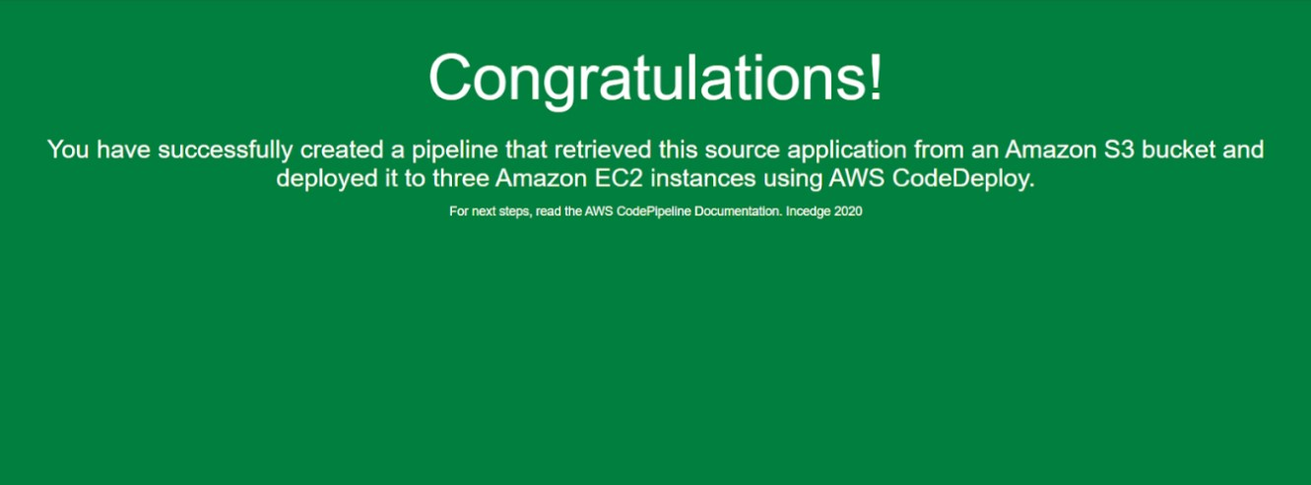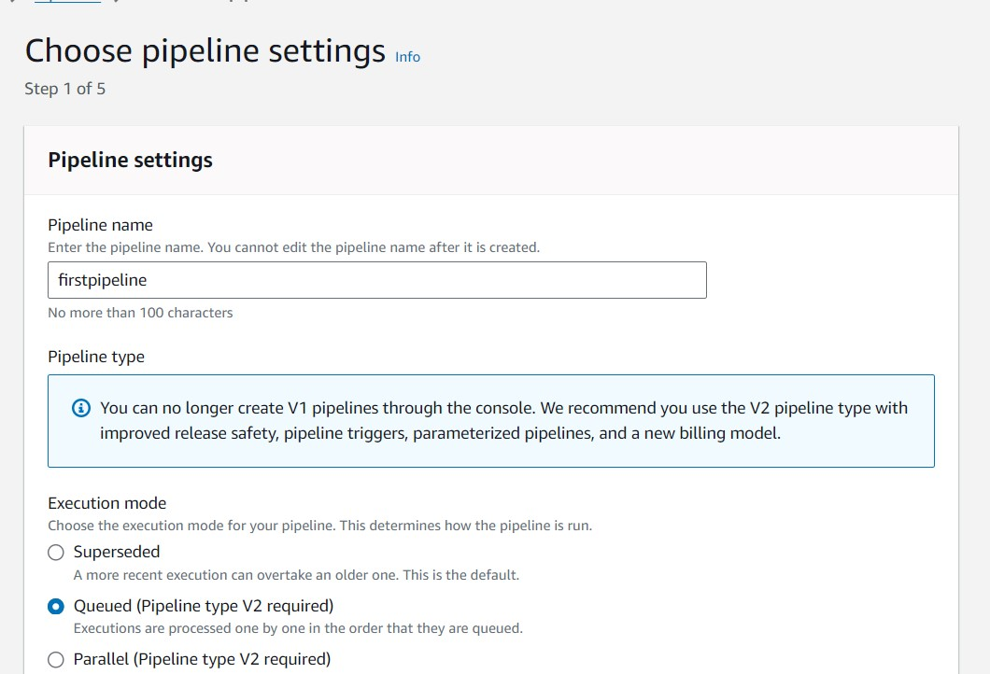

4)

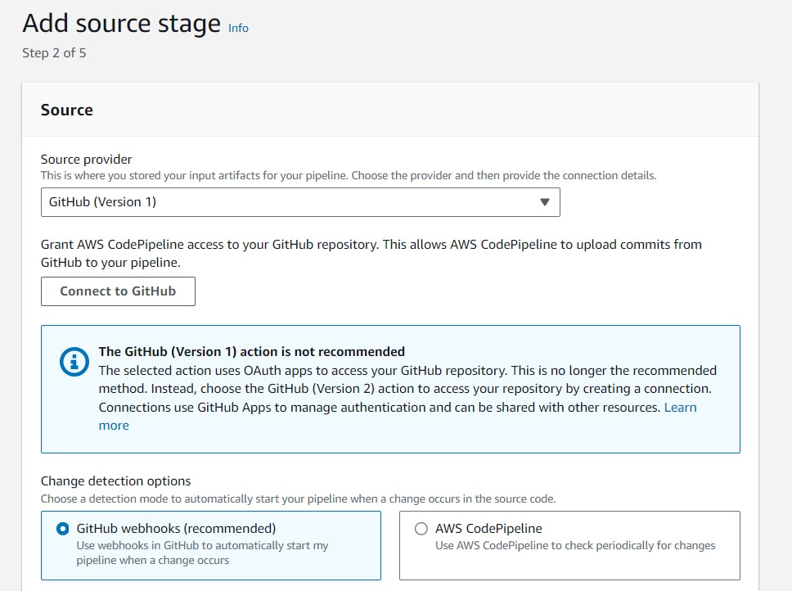

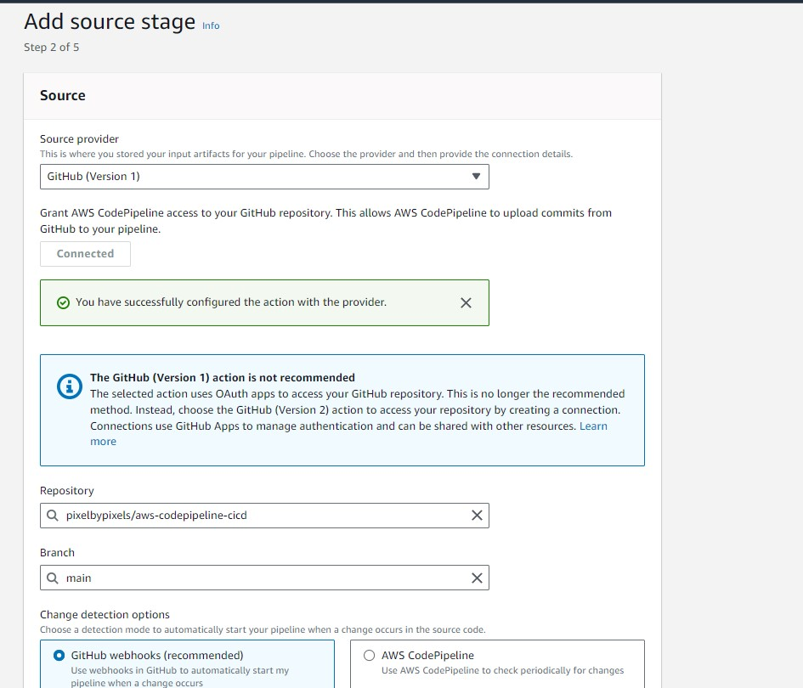

1. Go to the deploy stage and ensure the following settings.

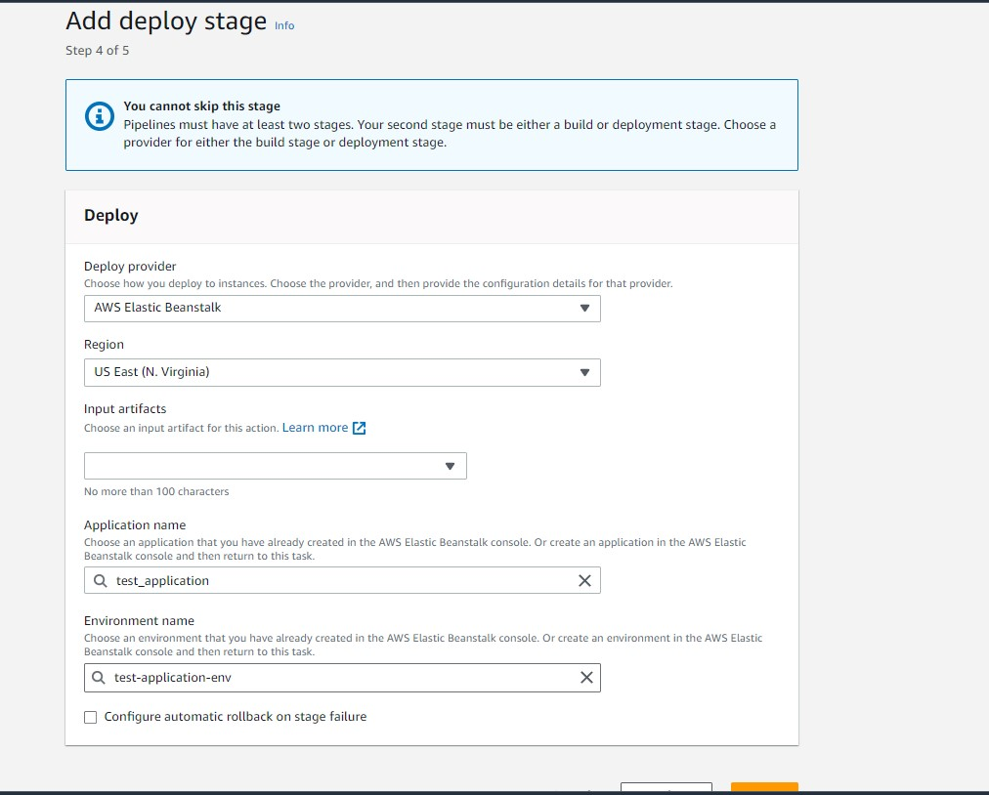

1. review the pipeline settings.

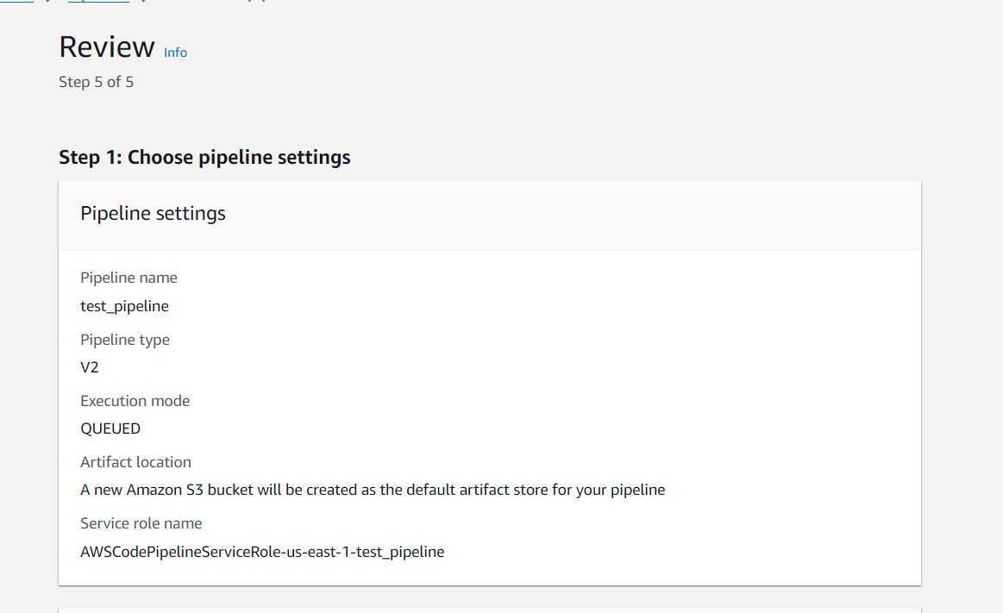

1. Then go ahead and check the URL provided in the EBS environment.

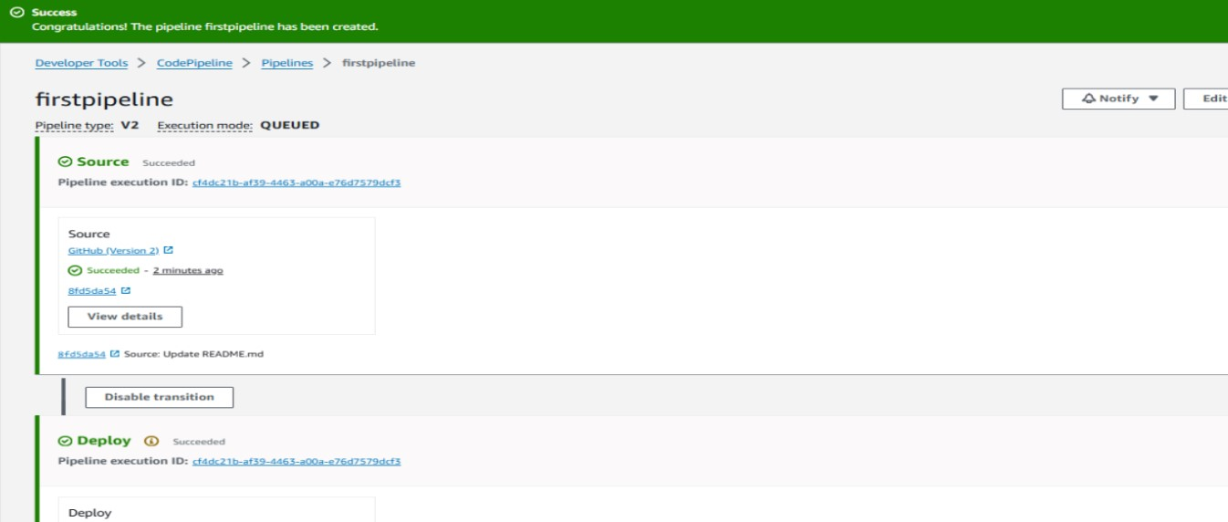

1. Go to the repository and make the changes in the index.html file and commit them

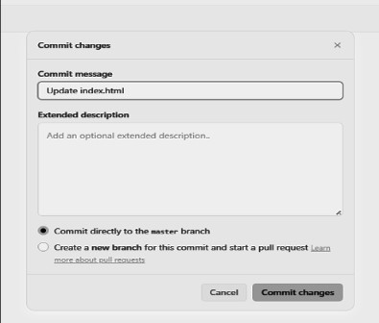

9)The changes that are committed can be noticed in the source panel in real time and to view the changes check the url (refresh it) and you can view the changes once the deployment section shows success.

